|  |
| --- |
| **Objective B: Planning** |

|  |  |
| --- | --- |
| **Develop criteria for the product/outcome**  a).**Develop rigorous criteria** for the product/outcome which can be easily evaluated by someone unfamiliar with the product.  b) Refer to the criteria they designed to evaluate the project product/outcome.  c) Explain any changes made and why they made them.  **Resource 4** | **Create a specification chart (see example below) align it with the assessment criteria**  **See the chart -exemplar Uptown** |

|  |  |  |  |  |
| --- | --- | --- | --- | --- |
|  | **Aesthetics** | **Function** | **User Friendliness** | **Costs** |
| **7-8** | The product looks like an ordinary mirror when it is powered off. When it is powered on there is no backlight ‘bleed’ and all UI elements are clear. | The mirror displays any and all useful information the user may want, like time, weather, a news feed and more. It is fully customizable/modular and does not clutter the view in any way. | The product can be used and customized by anyone from any age group with little to no effort. The language of the user interface can also be changed. | The product only costs around 600 AED to build, inclusive of shipping charges and does not compromise any quality for the lower price. |
| **5-6** | The product almost looks like an ordinary mirror when it is powered off. When it is powered on there is very little backlight ‘bleed’ and all UI elements are fairly clear to the point where they are legible. | The mirror displays many widgets with useful information the user may want, like time, weather, a news feed and more. It is customizable/modular to an extent and does not clutter the view that much. | The product can be used and customized by most people aged 12-50 with some effort. The language of the user interface can also be changed. | The product costs around 800 AED to build, inclusive of shipping charges and does not compromise any quality for the lower price. |
| **3-4** | The product resembles an ordinary mirror when it is powered off. When it is powered on there is some backlight ‘bleed’ and the UI elements are somewhat legible. | The mirror displays some widgets with useful information the user may want, like time, weather, a news feed and more. It is barely customizable/modular and can sometimes clutter the view. | The product can be used and customized by some people aged 18-50 with an adequate amount of effort. The language of the user interface cannot be changed. | The product costs around 1000 AED to build, inclusive of shipping charges. The price is somewhat justifiable by the overall quality of the product. |
| **1-2** | The product does not look like a mirror, when it is powered on it is not possible to read or see any of the UI elements. | The mirror displays no widgets with useful information the user may want, like time, weather, a news feed and more. It is not customizable/modular and almost always clutters the view. | The product is barely usable and cannot be customized in any way. The language of the user interface cannot be changed. | The product costs more than 1000 AED to build, inclusive of shipping charges. The high price is not reflected at all by the overall quality of the product. |

|  |  |
| --- | --- |
| **The planning and recording of the development process of the project.**  a) Present **a detailed and accurate plan** and record of the development process of the project from start to finish.  b) Provide evidence of planning through **timelines, milestones or other tools/strategies** (in the appendices).  **Resources 5** | **Action Plan:** |

**Visual Timeline: (https://i.imgur.com/F5R8Xmj.jpg)**

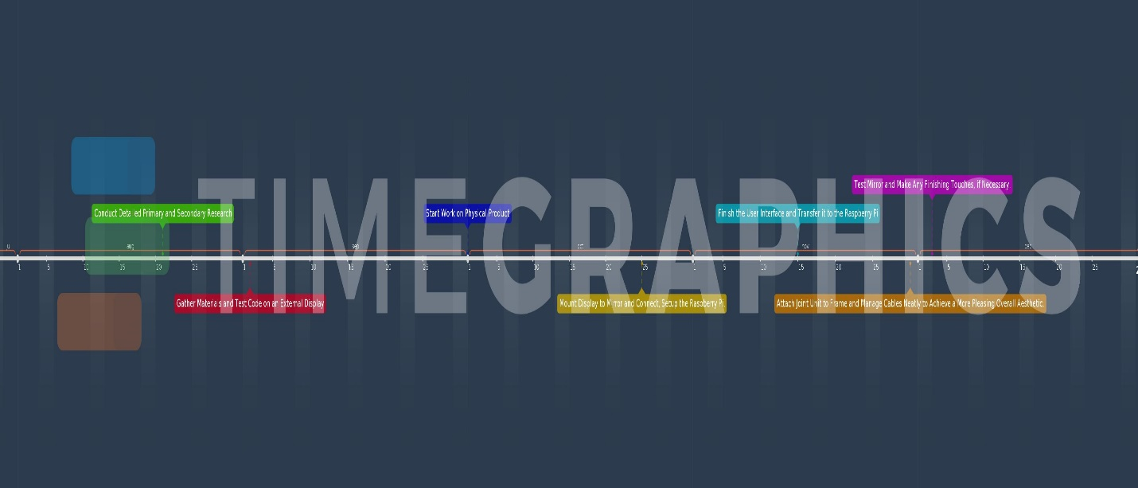

|  |  |
| --- | --- |
| **Self-management skills. ATL**  a) Outline the self-management skills they had when they started the project.  For example a **Gantt Chart, Scrum board/ -Resource 1 folder examples**    b) Have demonstrated to you that they have outstanding organization and time management skills.  c) Show how self-awareness of strengths and limitations guides effective planning and helped them complete their project.  d) Discuss the self-management skills they developed through the project. **For example a compass point visible thinking chart-See Resource 2 examples** | **Work Done Per Week (Up till now):**    **Choosing a User Interface:** |

|  |  |
| --- | --- |
| * Keep a basic log or timeline planning for the project **Lower Challenge Level** * Keep an organised and logical system of information **Lower Challenge Level**   **Low** | * Make plans that are logically sequential and efficient **Higher Challenge Level** * Demonstrate persistence and perseverance **Higher Challenge Level** * Practise ‘bouncing back’ after adversity (struggling, difficulties), mistakes and failures **Higher Challenge Level** |

|  |  |
| --- | --- |
| **Completed -Date**  **28/10/2018** | **Supervisor signed:** |